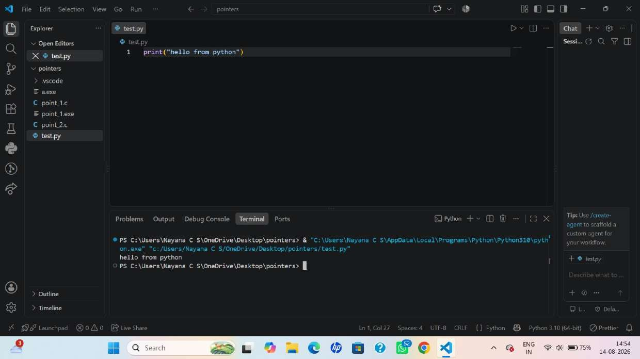
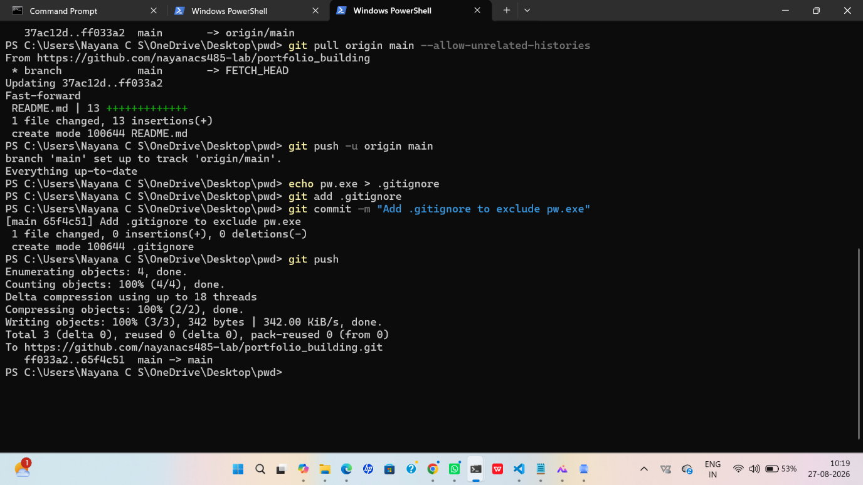
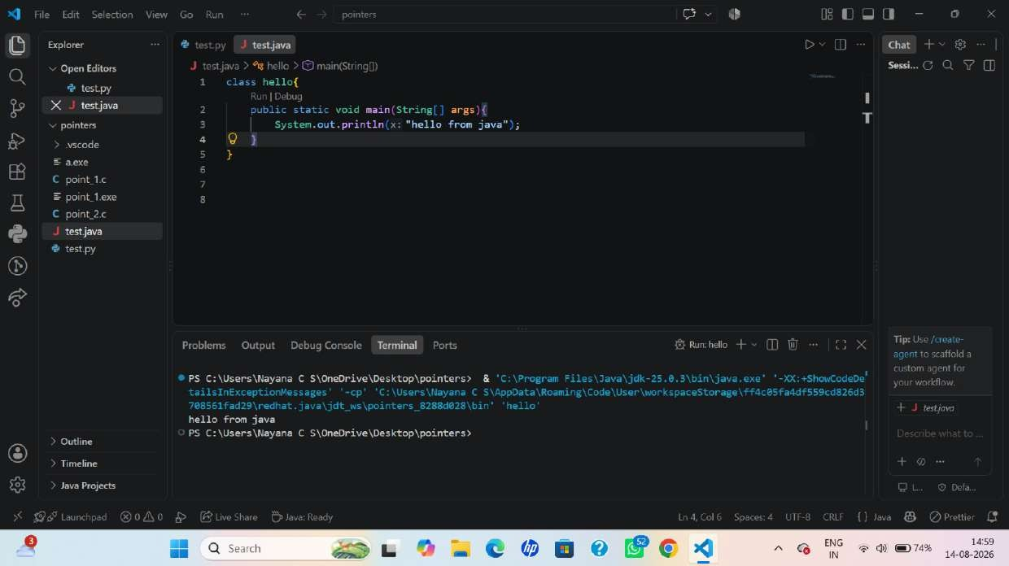
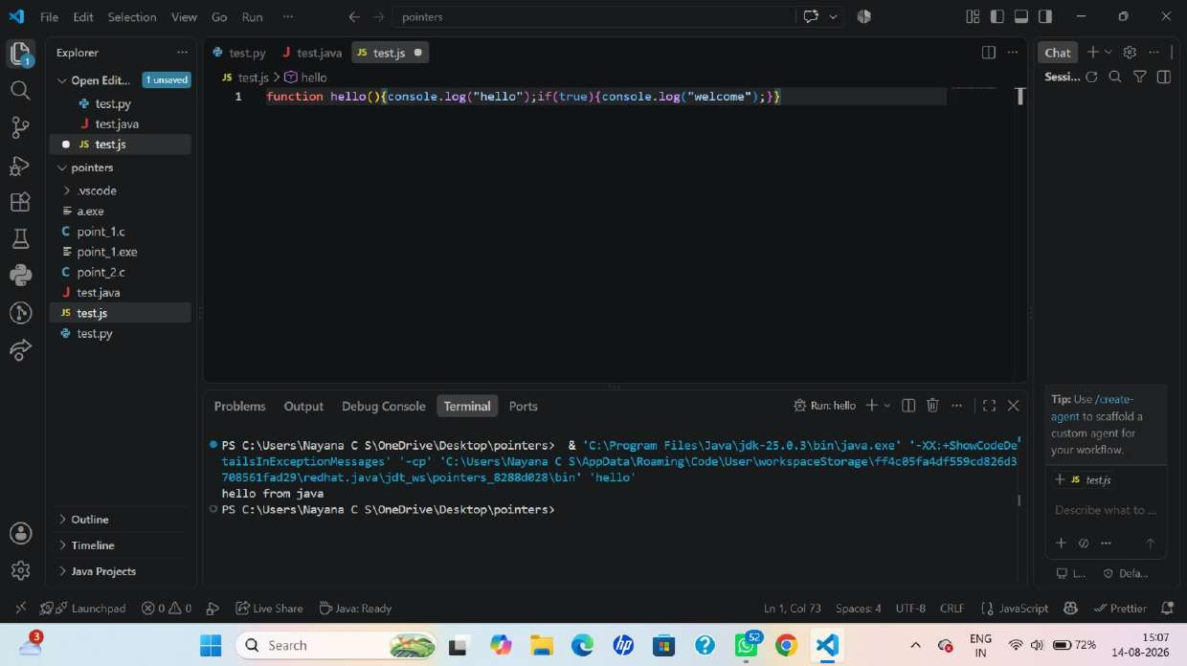

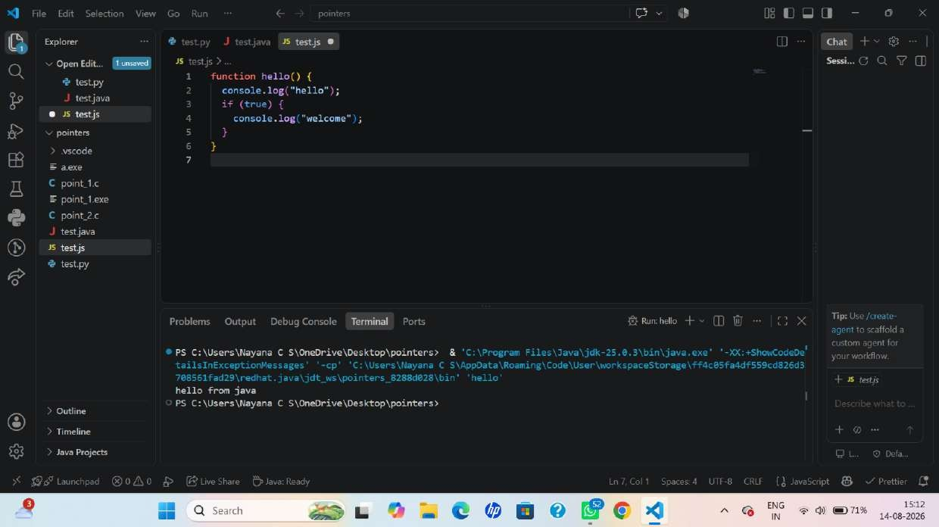
Source Control COMMIT. EDITMSG testjava Changes in 0818876 (J tile) o sample.html
v Repositories J test.java •e Git
You. minutes I (You)
Q poi.„ VS Code
class hello( ges 3. Conventional
public static void main (Strine[)
Message (CL.. System-out. value of • "+c+"end Commits(vivaxy.vscDde-
4
Onalcommits)
7 o Helper for
Writing conventiona
I commit
v G.. t9m,to O
Which one would
O initial com... you like to install? Or
• initial commit if you want a specific extensiom let me
Problems• Output Debug Console ports know the name or publisher-
PS C: Nusersv•ayana C create node lee644 point_l. c create rode Iøe644 exe J testy-am create node Iøe644 point_2. c create rode tøe644 sample. html create 'Bde Iøe644 test-java create "Ode Iøe644 test. is create rode Iøe644 test. py
> GitLens @ PS C: Wsers\Nayana C test. js
X-9 main Launchpad @ O e '_ive Siu re Read'/ $ naysnacs48S-Iab IS minutes Ln Soaces: 4 Java
17:29
097%
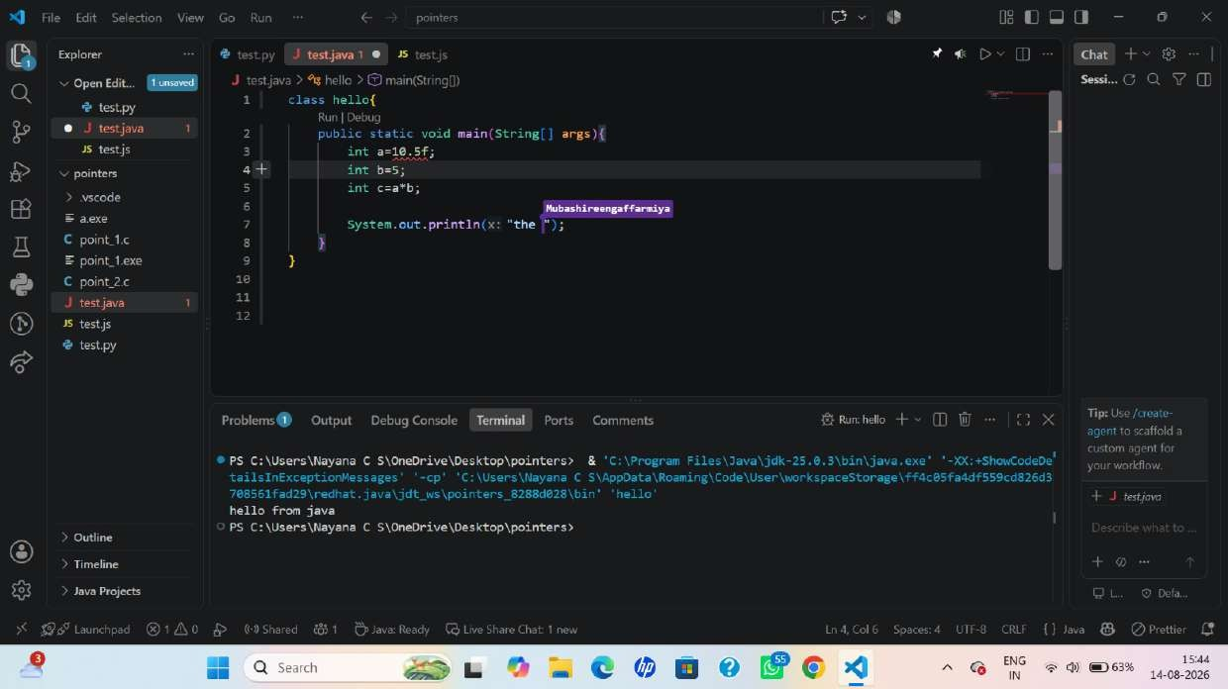

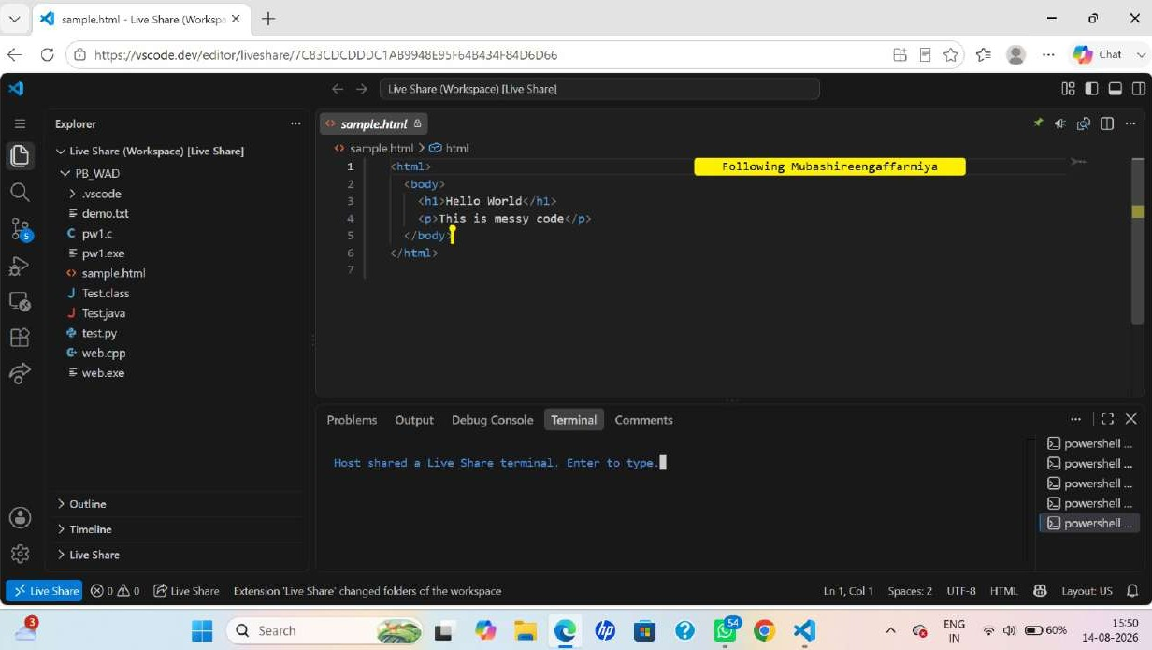
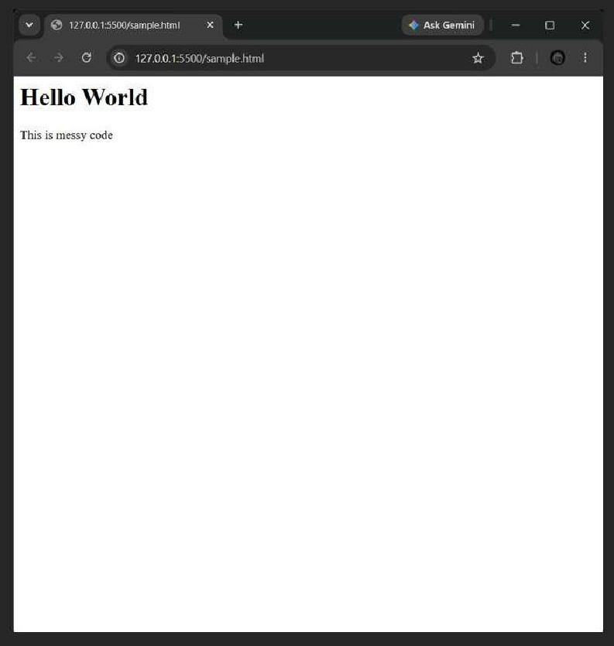
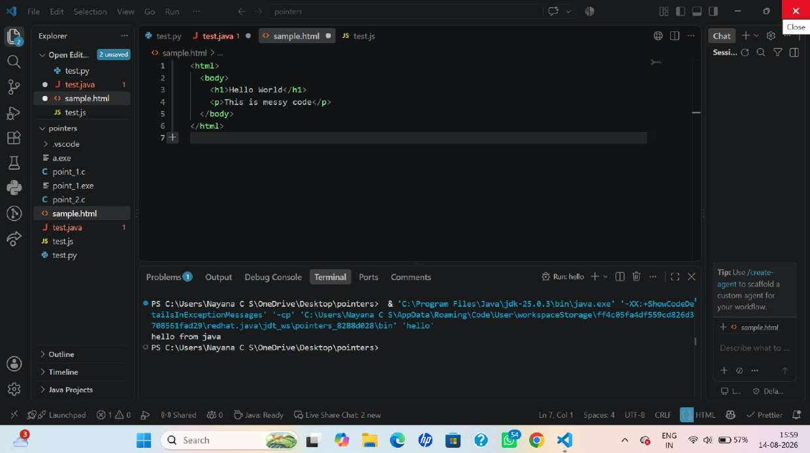
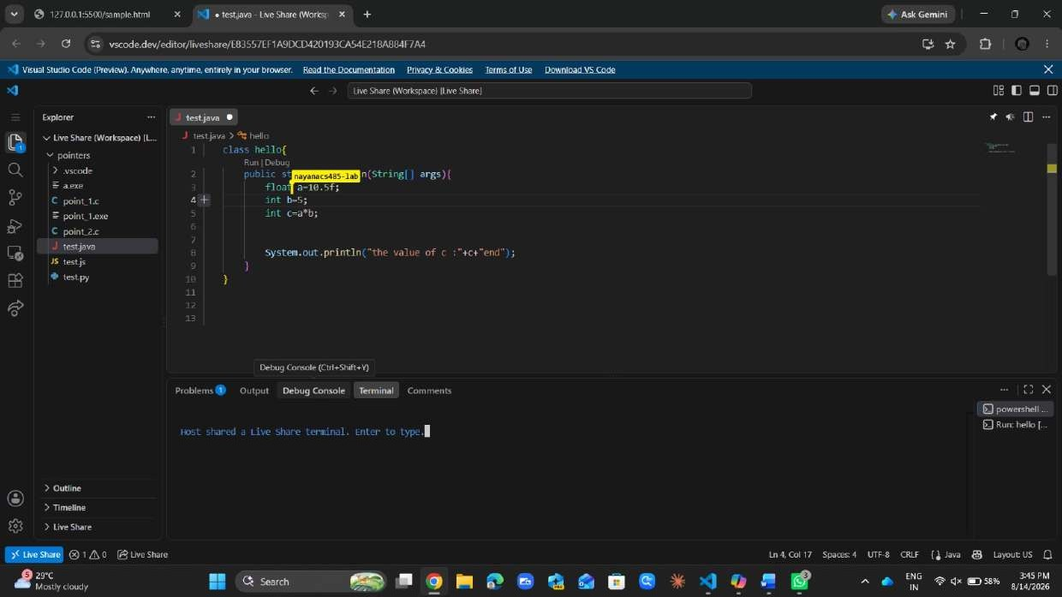
File Edit View
Here is a simple comparison table you can use for your notebook:
Extension / Tool Main Purpose What it does Effect on daily work Best used for

x
€93

Prettier Code formatting Automatically formats code with consistent spacing, indentation, and style Makes typing and editing cleaner and easier Every project
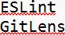
Code correctness Finds coding errors, bad practices, and style problems Helps catch mistakes while coding JavaScript/TypeScript projects
History & collaboration Shows Git history, authors, changes, and blame information Makes it easier to understand who changed code and why Projects using Git
Live Share Collaboration Allows multiple people to edit and work on the same code in real time Makes pair programming interactive Team/pair programming
Discussion Answers
- Which extension changed your day-to-day typing/editing experience the most?
Prettier, because it automatically formats the code and saves time spent fixing indentation, spaces, and brackets.
- Which extension is about the code itself vs. collaboration/history?
Code correctness/ formatting: Prettier and ESL-int
Collaboration/history: G_itLens and Live Share
- Which would you keep enabled for every project?
I would keep Prettier and enabled for most projects. ESL-int can be enabled when working with JavaScript/ Typescript, while other language-specific extensions can be used only when needed.
4. How did Live Share change pair programming compared to screen sharing?
With screen sharing, usually one person controls the computer while the other watches. With Live Share, both people can work directly in the same code environment, making pair programming more interactive and allowing faster debugging and collaboration.
Ln 22, Col 254 1,720 characters Plain text 100% Windows (CRLF) UTE-8

